the real-time communication with the live speakers and surprise events!
“BIC Festival 2020”, Revealed the conference program, which has the excitement of an offline event
- bring a sense of real-world excitement online… the system allows audiences to have a real-time communication
- The developers’ back story video and surprise events will appear in the session
- Conference free-pass ticket available for no cost once joining the BIC website

--Busan, Korea— October 12, 2020 - Busan Metropolitan City (Acting Mayor Sung-Wan Byeon), Busan IT Industry Promotion Agency (President & CEO In-Sook Lee), and Busan Indie Connect Festival Organizing Committee (Executive Chairman Tae-Geon Seo) announced that the conference schedule of BIC (Busan Indie Connect) Festival 2020-Untact (zero contact) Live will be released on 12th.

The organization mainly will focus on bringing a sense of real-world excitement online through BIC festival conference this year. While the conference session, speakers, and audiences can have real-time communication through the platform.

Even after the conference session, the audiences can join “a cocktail party” board on the website to discuss the session or share some relevant information

The conference will be held from October 20th to 24th, 11 AM – 6 PM every day.

▶1st day: Speech sessions by Im-Sang Ryu(SUKPAJUNG SEOUL MUSEUM), Min-Seok Do(CEO of GamBridzy), Hae-Min Kim(CEO of COSDOTS) ▶2nd day: Speech sessions by Kwangsub Shin (Epic Games), Inigo Quilez(Freelance Artist), Johnson Lin(Event Organizer of IGDA Taiwan&IGDShare), and Talk show session ▶3rd day: Speech sessions by Lawrence Mien(Director of Partner Experience of Xsolla Inc.), Sang-Woo Park(CEO of SouthPAW Games), Sae-hoon Lee(CEO of Pixellore Inc.), Bo-Sik Shin(CEO of Toward Inc.) ▶4th day: Yong-Hyun Lee(Manager of NAVER Cloud), Reuben Sim(Senior Manager of Eliphant Pte Ltd and GameStart Asia), and Talkshow session ▶5th day: Speech sessions by Chris Hewish(President of Xsolla Inc.) and Reruns of the previous sessions

The committee has also prepared various events. There will be quizzes and gift voucher prizes to 10 people in the audience before the end of each conference session. They will reveal the back-story video of the BIC exhibit developers in between sessions.

All conference sessions will be shown only on the scheduled time including reruns. If you join the BIC website, you can receive a free-pass ticket that allows access to all conference sessions for no cost.

BIC Festival 2020 will be more convenient this year due to being able to access the festival through the official website from any location of your choice from Oct 19th to 25th. Through the website, visitors will enjoy the real-world festival’s excitement and communication with the developers just as the offline event. For more information on the details, visit the official website.

Tae-Geon Seo, Executive Chairman of the Busan Indie Connect Festival Organizing Committee, said, “The committee built a system with various features to deliver the conference online as good as offline. We expect a lot of interest in the conference since the organization has prepared a lot of content from the information of the industry, the developer’s back story video, and surprise event”.

About Busan IT Industry Promotion Agency
Busan IT Industry Promotion Agency operates the Busan Global Game Center to promote the Busan game industry with the support of Busan Metropolitan City, Ministry of Culture, Sports and Tourism, and Korea Creative Content Agency. Busan IT Industry Promotion Agency hosts the BIC Festival every year with Busan Indie Connect Festival Organizing Committee, to find and promote local indie games with potential. -The end-

[image provide_ BIC committee] BIC Festival Representative image

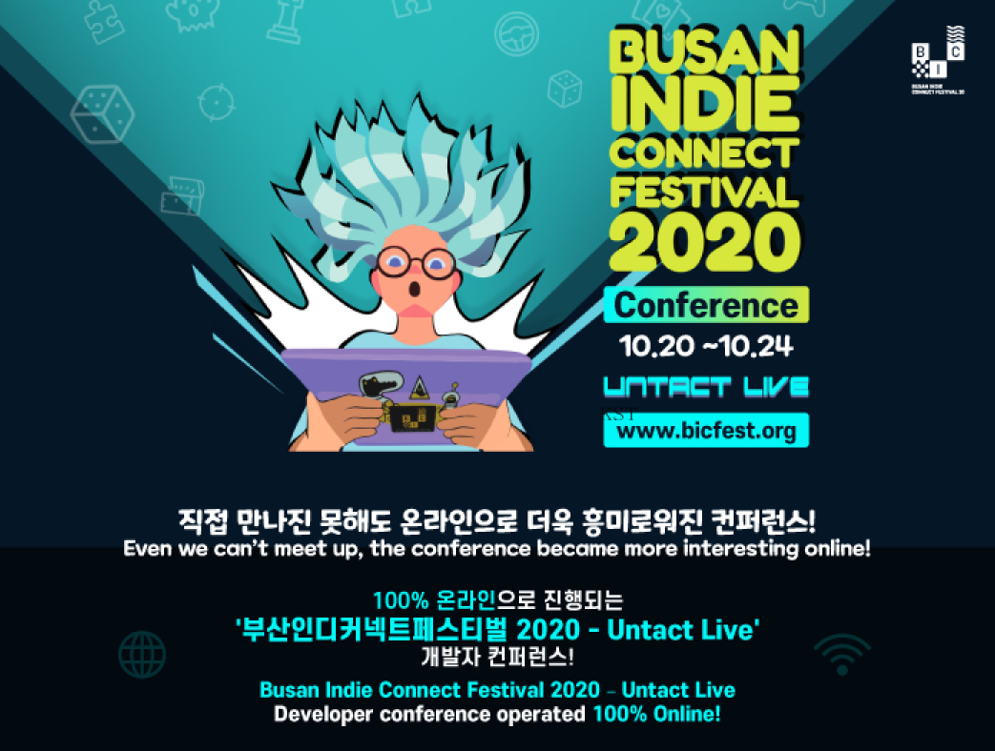

 | For more detailed information, please contact 이고은 과장 from the Busan Indie Connect Festival Organizing Committee at +82-2-585-5506
BIC Festival Official website | http://bicfest.org/

